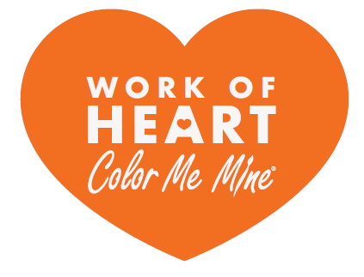

**Boys & Girls Club Photo Release Confirmation**

I, ______________________________________, from the ______________________________________,

(Print Boys & Girls Club representative name) (Print Boys & Girls Club site name)

acknowledge that the Boys & Girls Club is required to have signed Boys & Girls Club photo releases on file for each club and staff member that will be participating in the Color Me Mine Work of Heart Community event.

As a representative from the Boys & Girls Club and by signing below, I am confirming that the Boys & Girls Club has all required photo releases for the club and staff members that will be participating in the Work of Heart Community event. I understand that I am releasing Color Me Mine from all liability should any participant be found not to have a signed photo release.

I also understand that all pictures and video captured at the Work of Heart Community event held in September 2019, as well photographs captured when the club members receive their fired projects when delivered to the club, may be used for posting on social media by Color Me Mine.

_____________________________________ _______________________________

Signature Date

_____________________________________

Print Name