 ›

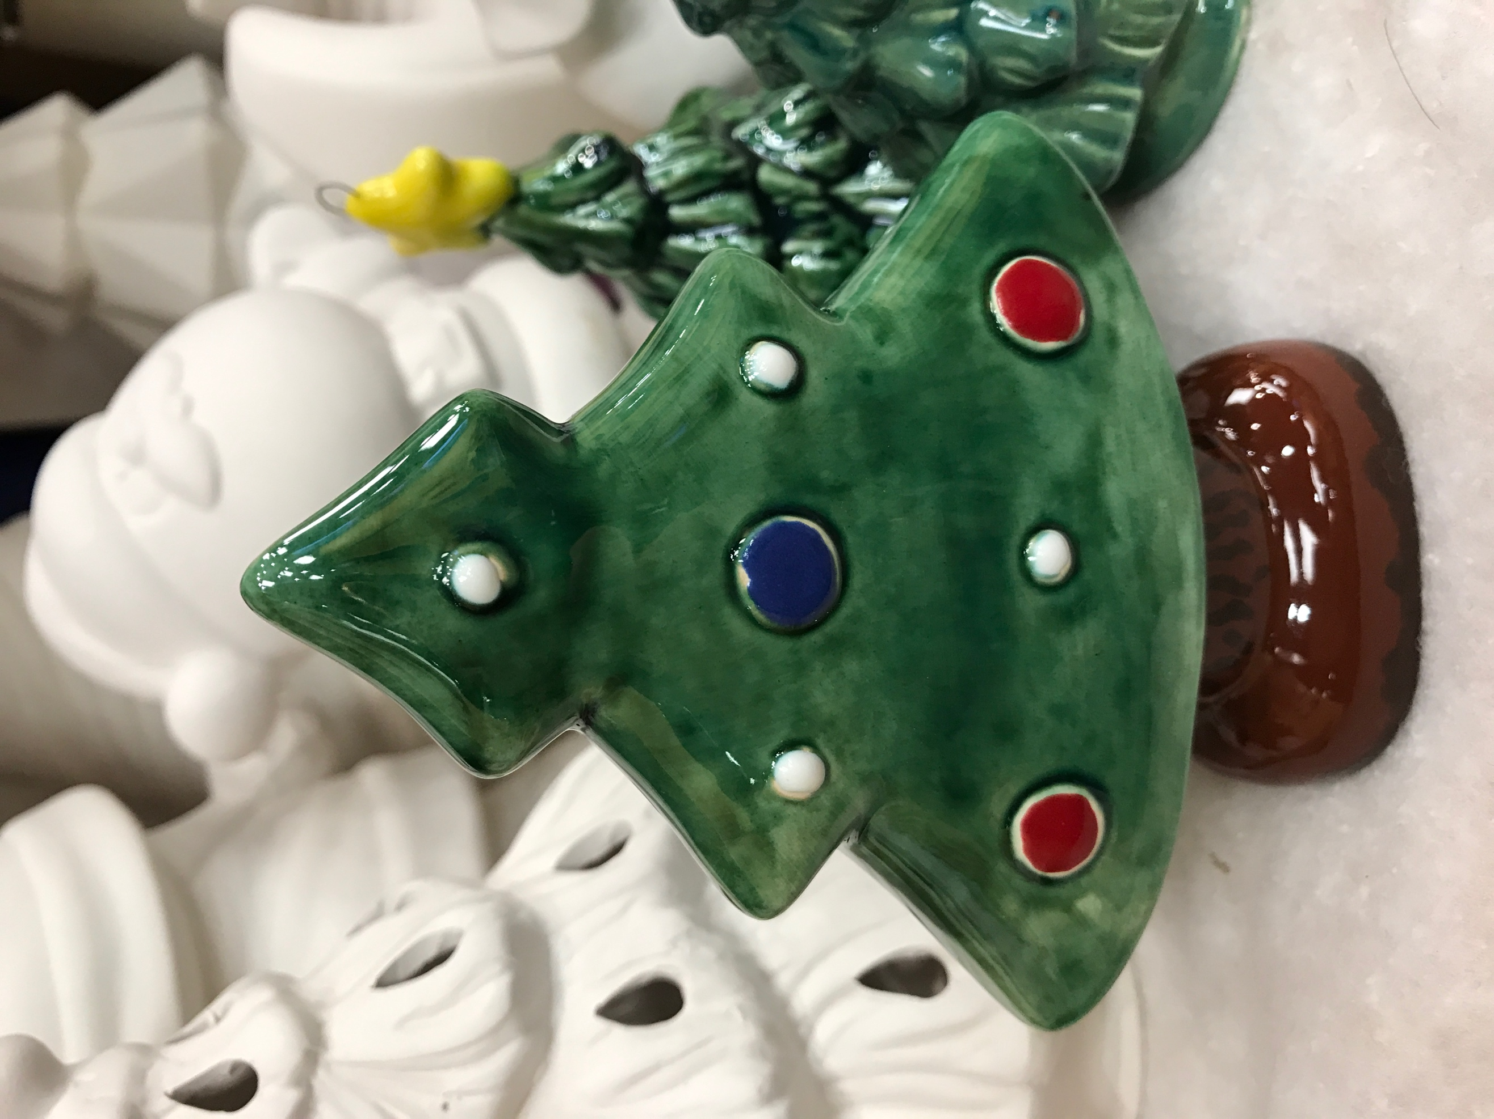

December 11th

All Day Wilhe Supplies Last.

$10 Hootie the Owl