Sunday | Monday | Tuesday | Wednesday | Thursday | Friday | Saturday
Pre – Order Your Christmas Trees Today! |  |  |  |  | 1    6pm-9pm Wear PJ’s for $2 Paint Time | 2  
3   | 4    OPEN  11am-5pm | 5    ½ Price Paint Time BYOB  6pm-9pm | 6 | 7    ½ Price Paint Time BYOB  6pm-9pm | 8  6pm-9pm Wear PJ’s for $2 Paint Time | 9  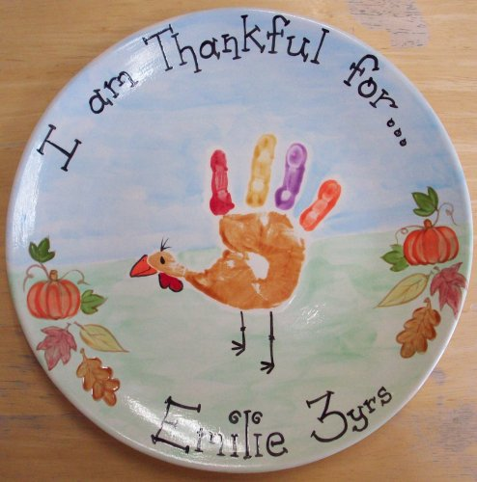  Turkey Plate Workshop  12pm-9pm
10 | 11  OPEN  11am-5pm | 12  ½ Price Paint Time  BYOB  6pm-9pm | 13 | 14  ½ Price Paint Time BYOB  6pm-9pm | 15  6pm-9pm Wear PJ’s for $2 Paint Time | 16
17 | 18   | 19  ½ Price Paint Time  BYOB  6pm-9pm | 20 | 21  ½ Price Paint Time BYOB  6pm-9pm | 22  6pm-9pm Wear PJ’s for $2 Paint Time | 23
24 | 25 | 26  ½ Price Paint Time  BYOB  6pm-9pm | 27 | 28   CLOSED | 29    $2 Paint Time ALL DAY | 30
November 2019

